PHASE 2: Requirement Analysis Phase
Project Team Members
M.G Misriyathul Ibrahima
S.M.B.N Meera Jenira
V.Mohana
P.Mutharasi
S.A.K. Muthu Ameena

Project: Implement Client Script & UI Policy (Incident)
ServiceNow – Incident Management

Phase Objective
To identify the exact business rules, fields, script types, and ServiceNow components required for the implementation.

Functional Requirements
- The system shall detect Impact = High.
- The system shall make Assigned To mandatory when Impact is High.
- The system shall control the Urgency field when Impact is High.
- The system shall automatically set Urgency to High when Impact changes to High.
- The system shall prevent submission when Assigned To is missing for a High Impact incident.
- The system shall prevent State changes through direct list editing.
- The system shall allow State changes through the Incident form.
- The UI Policy behavior shall reverse when its condition becomes false.

Non-Functional Requirements
- Simple and maintainable configuration.
- Immediate feedback to users.
- Consistent Incident data entry.
- Lightweight client-side implementation.

Technical Mapping
UI Policy → High Impact Control; UI Policy Action → Urgency/Assigned To behavior; onChange → automatic Urgency update; onSubmit → Assigned To validation; onCellEdit → State list-edit restriction.

Requirement Evidence
The uploaded project recording shows the Incident UI Policy creation flow and the condition being configured for Impact = High.

Project Evidence – Screenshots
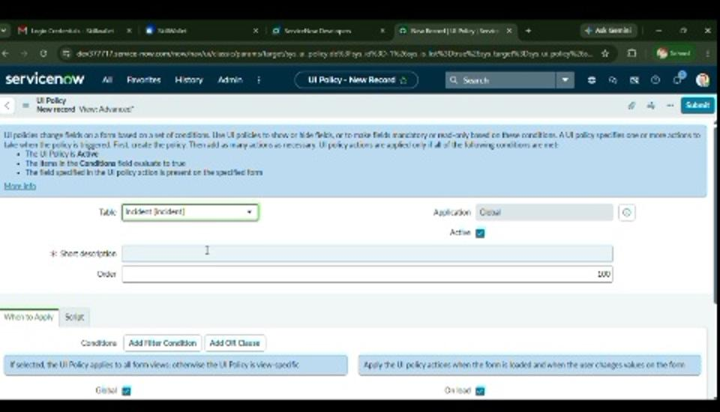
Figure 2. New UI Policy form for the Incident table.
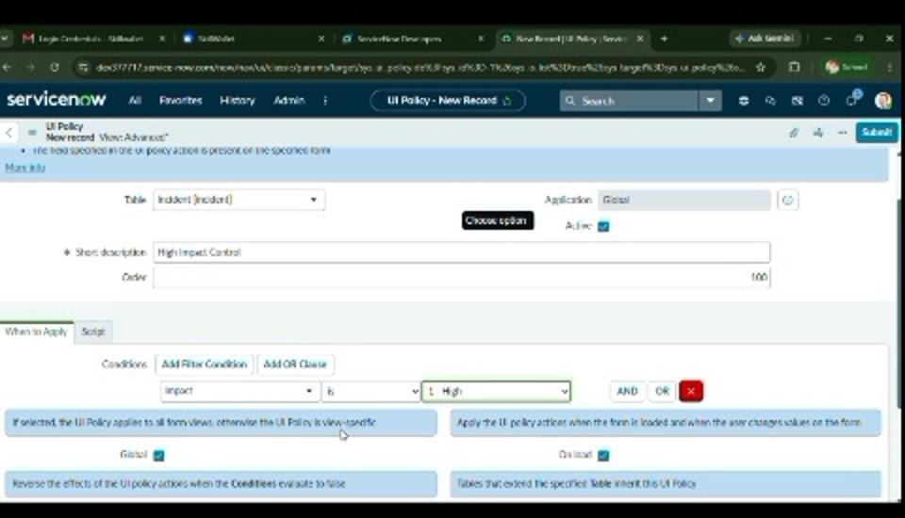
Figure 3. UI Policy condition configured around Impact = High.

Phase Outcome
The functional, non-functional, and technical requirements were identified and mapped to UI Policies and Client Scripts.

